PCB Construction – July 11 2019

1. Source Article <http://www.technoblogy.com/show?2FCL> - Includes a through hole PCB for panel mounting.
2. Reference files on GitHub - <https://github.com/JohnGENZ/ZL3TILProject>
3. Circuit Diagram

1. Performance

1. Our Board is for chassis mounting and as we design it here it is single sided with no holes

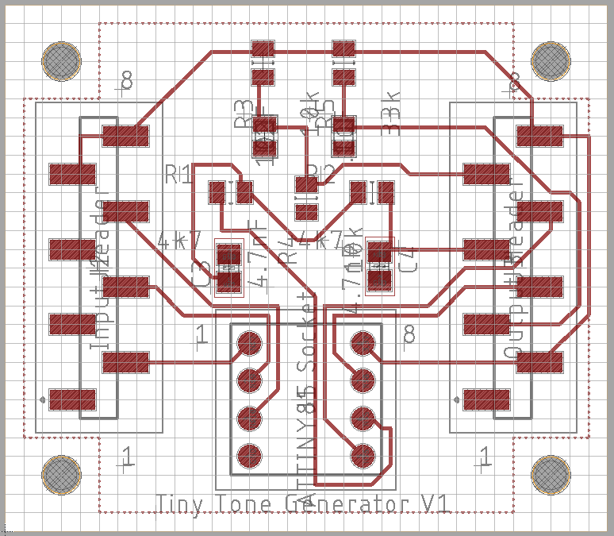

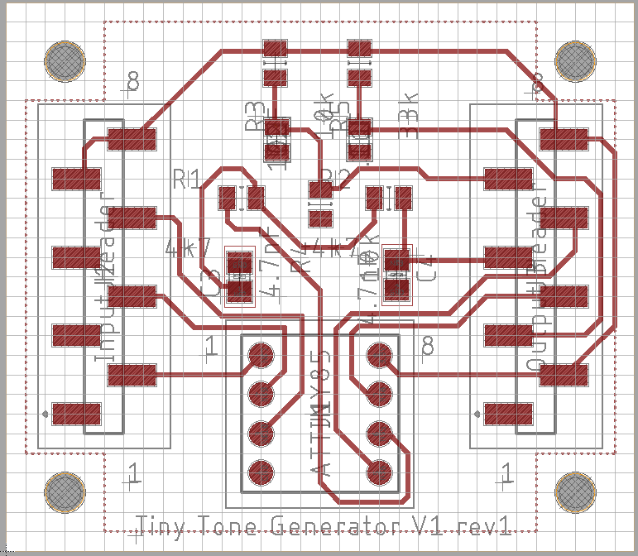

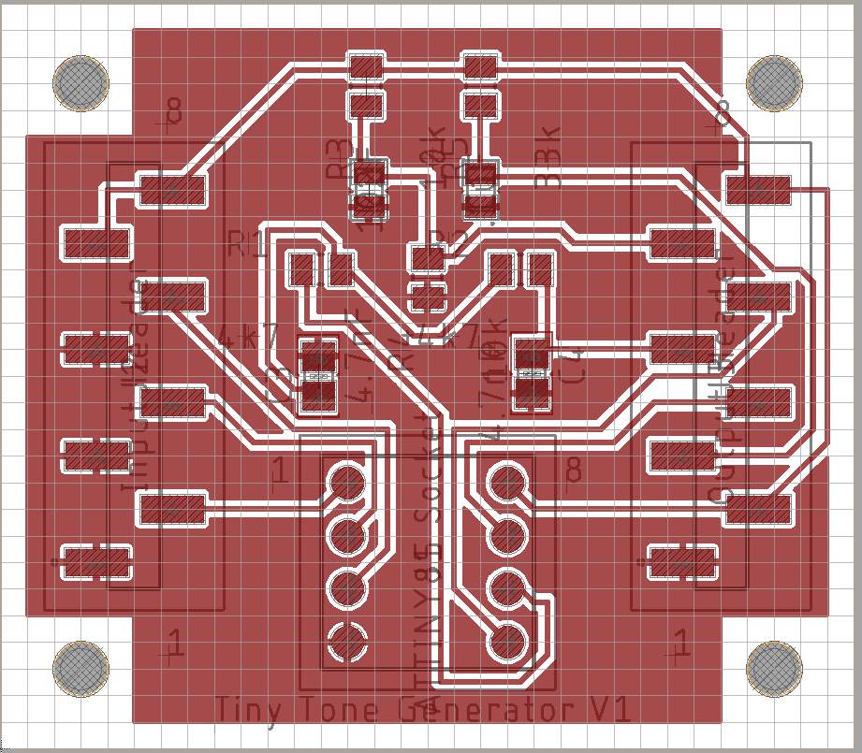

1. The double sided version.

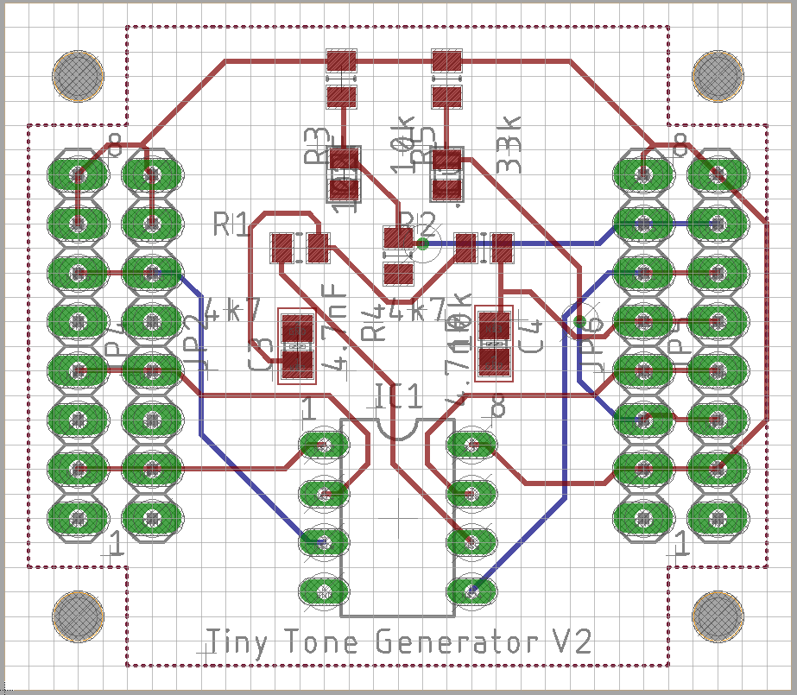

1. CAD packages and SMD components.

CAD is quick, and more and more components are only available as SMD parts. (Some SMD component can be purchased on breakout boards – at a cost.) <https://www.sparkfun.com/products/10124>

CAD software - Eagle, KiCAD, Altrium, OrCAD, PADs ……

Eagle well supported by Open Source Community – Adafruit, SparkFun make Eagle drawings available. Supported by the major parts suppliers e.g. Mouser, Digikey.

1. Eagle is found here: <https://www.autodesk.com/products/eagle/free-download>

2 layer Eagle is free – board size and other limitations apply – but probably good enough for us. Fabrication services also have very low prices for “small” boards – so it costs a lot more if you need to go larger. 2 layer boards can also be a good choice for prototyping because it is easier to get probes to all parts of the circuit.

Other versions are compared here: <https://www.autodesk.com/products/eagle/compare>

1. Eagle looks like this: ……
2. Workflow:
   1. Choose key components
   2. Create a schematic drawing
   3. Layout the PCB
   4. Generate a Bill of Materials
   5. Make the Board
   6. Assemble the board.
3. Selecting Components:
   1. There are parts libraries available from different places:
      1. Adafruit. <https://github.com/adafruit/Adafruit-Eagle-Library>
      2. Sparkfun <https://github.com/sparkfun/SparkFun-Eagle-Libraries>
      3. Suppliers, eg Mouser <https://nz.mouser.com/ProductDetail/Wurth-Elektronik/885012207098?qs=%2Fha2pyFaduhWLwq%252BImdxjPxGLxfkz82R3MUHb0DTRlyTmZ0GqCfc7w%3D%3D>
      4. Assemblers, eg Seeed <https://www.seeedstudio.com/opl.html>
   2. Check availability of components – capacitors and some connectors are hard to get at the moment.
4. Create a schematic drawing:

This tutorial covers the basis well. <https://learn.sparkfun.com/tutorials/using-eagle-schematic/all>

* 1. Start Eagle – you want to start a new project.
  2. After creating the project, create a new schematic.
  3. Place the components on the drawing. Use the library manager to browse to the parts libraries and add parts to the schematic
  4. V1 – empty
  5. V1i – all parts – note that connectors used even if at the end all we want are the solder pads.
  6. V1ii – lay out parts
  7. V1iii – join the dots
  8. V1iiii – all joined up
  9. V1iv – prettified
  10. V1v – values added, ready for laying out a board.

1. Layout the PCB:

Choose the design rules:

1. These are the rules that govern how the board can be made.
2. Most typically they relate to the capability of the fabricator or the fabrication process. The answer is different if you want to mill a board, or hand drill it, or it may depend on how you apply the resist. They may also relate to the electrical properties of the circuit – maybe for current carrying or rf performance.

Eg <http://support.seeedstudio.com/knowledgebase/articles/447362-fusion-pcb-specification>

1. Don’t use minimum values unless you really must. 6mil spacing and 10 mil traces are very small! 0.5mm is probably the smallest dimension for milling.
2. default JGE Seeed V6 10mil Trace free.dru is a modified version of the Eagle default files for use with the free version of Eagle (2 layers).

Make a board

1. Click SCH/BRD to generate a blank board.
2. Set the size of the board – note that pin spacing is usually .1 of an inch so the grid is good at 0.05 of an inch. Our board is 1400mil by 1600mil (35.5mm by 40.64mm)
3. Put the mounting holes on the board!!! 2.5mm = 98.425 mil
4. Load the DRU file!!
5. Place the components Start point, with components available
6. V1vi – Components placed – needs ground pour.
7. V1vii – Components prettified – ground pour added (Ground pour is a polygon with isolate set to 12mil).
8. V1viii – routing complete
9. V1vii – Components prettified – ground pour added.

Notes on the auto router

1. it should usually complete more than 80% - if not try a different component placing.
2. As you get better you will get more “picky” about the auto router – it does an OK job for lower frequencies and good signal levels.
3. The autorouter completes from where the board as routed. Try routing “important” signals manually before running the autorouter. See <https://www.autodesk.com/products/eagle/blog/are-you-better-than-the-autorouter/>
4. The autorouter sticks to the grid – this can make for some strange results.
5. Sometimes the autorouter does not like the ground pour on a single sided board – try removing it (ripping it up) if the autorouter is not working properly.
6. Manual routing and connecting up the ground pours is usually obvious – but may not be pretty. The autorouter is limited in the number of vias and corners a route can have.